

ProEFI Xpedition Turbo Kit Installation Instructions

- Remove the back cab or bed depending on the model.
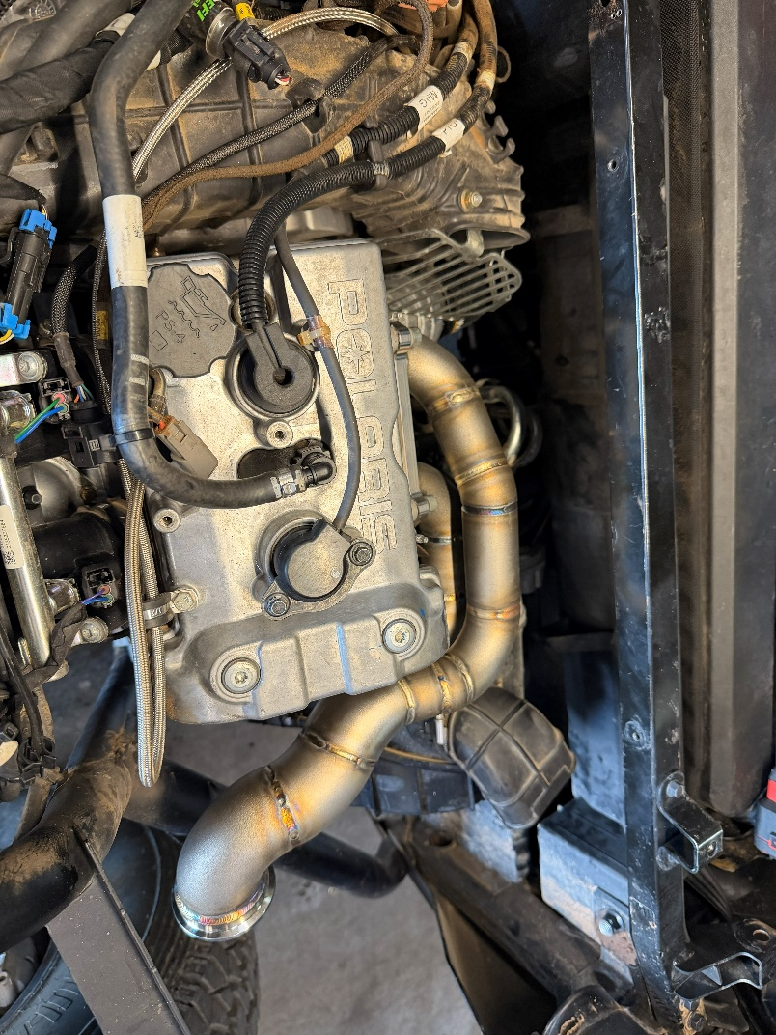
- Remove stock air intake piping and factory airbox.
- Remove stock exhaust, header, and all heatshields.
- Remove dipstick tube and oil filter.
- It is necessary to cut off, sand down stock exhaust tube bracket on frame rail on passenger side to clear turbo and wastegate actuator arm. Be sure to seal with black spray paint after smoothing down the area. 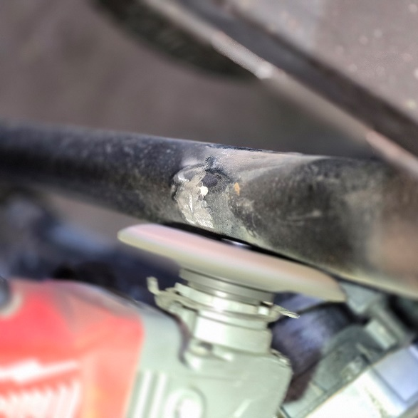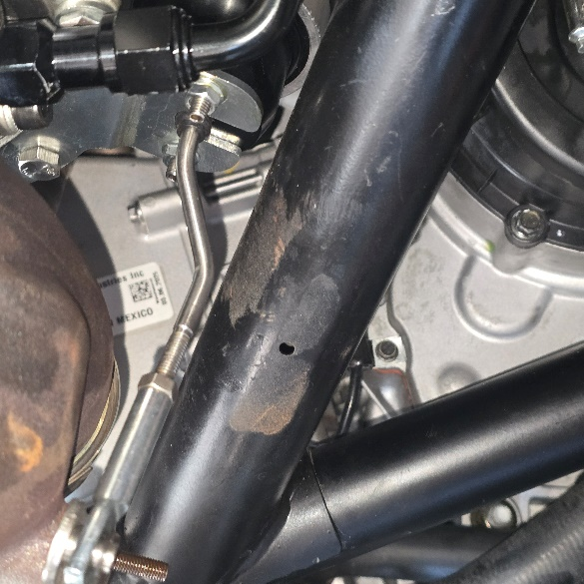

- Install new oil filter adapter with turbo feed fitting and oil pressure sensor if purchased/supplied.
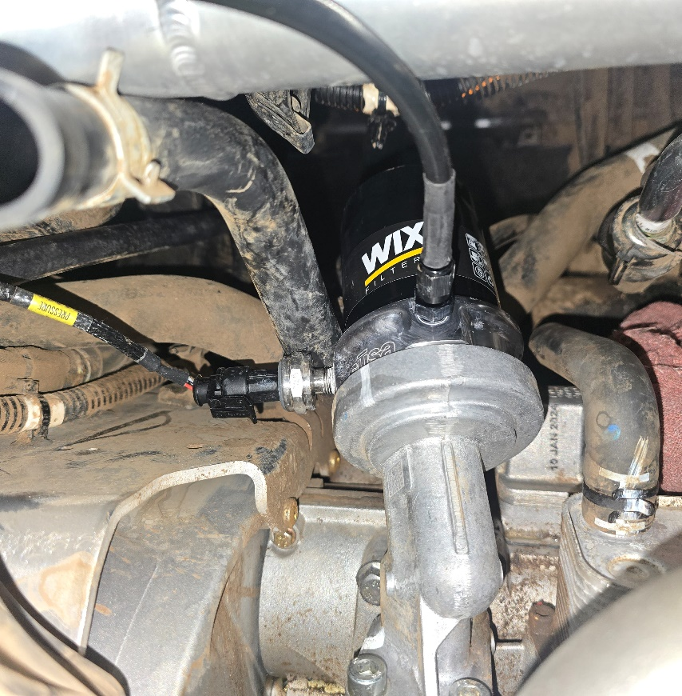
- Install new dipstick tube and turbo drain line. Drain line will route forward towards fire wall and left over the ac compressor housing towards the dipstick/drain fitting. Secure with supplied clamp.
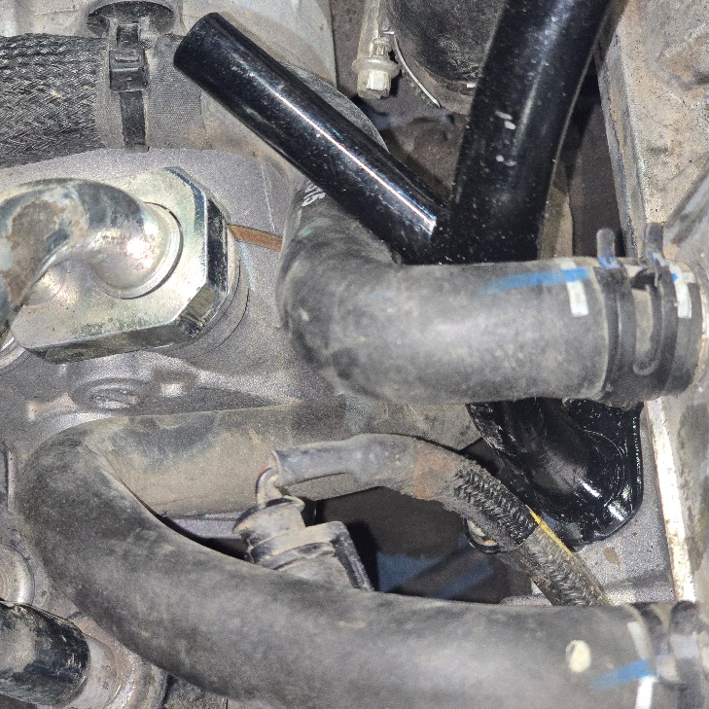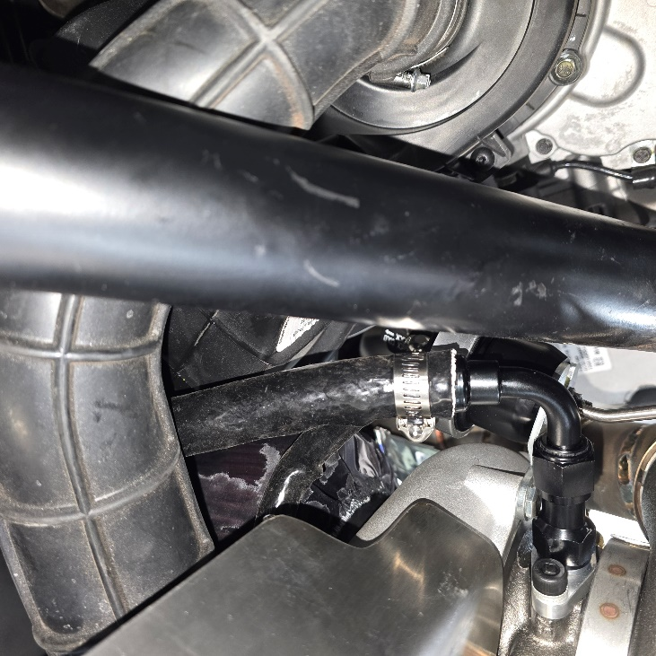
- Remove O-ring from old dipstick tube and place on new dipstick tube flip oil dipstick p clamp upside down to relocate dipstick tube 1 inch lower
- Install new header with OEM hardware
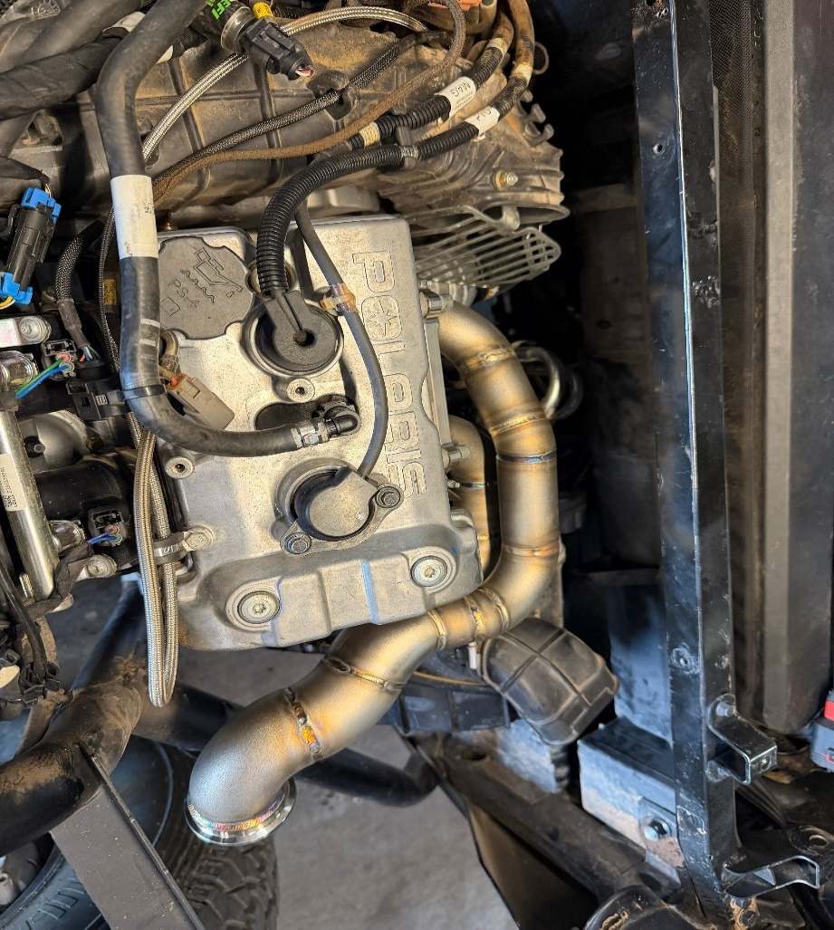
- Make sure turbo is clocked properly for fitment. May have to loosen cartridge bolts to clock. Install turbo drain fitting, turbo feed fitting with provided hardware.
- Using provided hardware and gaskets install turbo to new header. Make sure v-band mating surfaces are flush before tightening. (do not completely tighten at this time! Leave turbo slightly lose for fitment.)
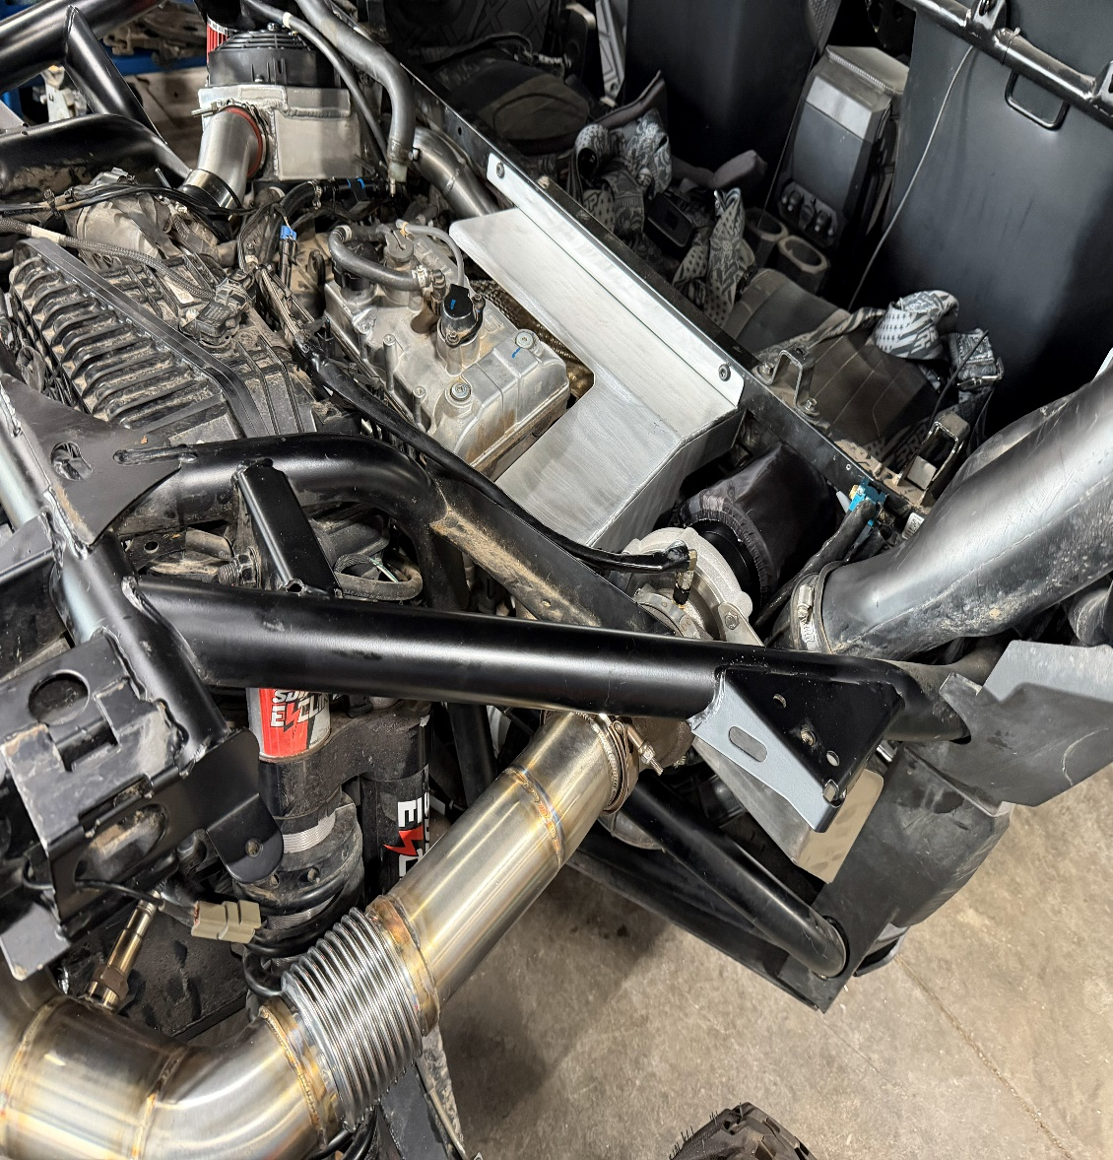
- Install turbo downpipe to back of the turbo. Be sure everything lines up properly before tightening all the hardware. (Make sure to go back and re tighten all turbo hardware permanently at this time.)
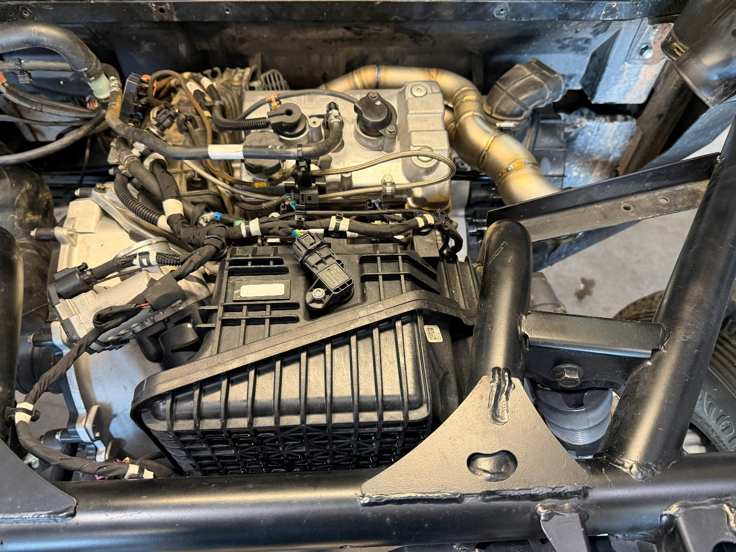
- Install rear muffler and connect to turbo downpipe, leave loose at this time.
- Route turbo feed line from oil filter adapter straight back towards fire wall , along rear seat frame rail to turbo. Routing shown in red.
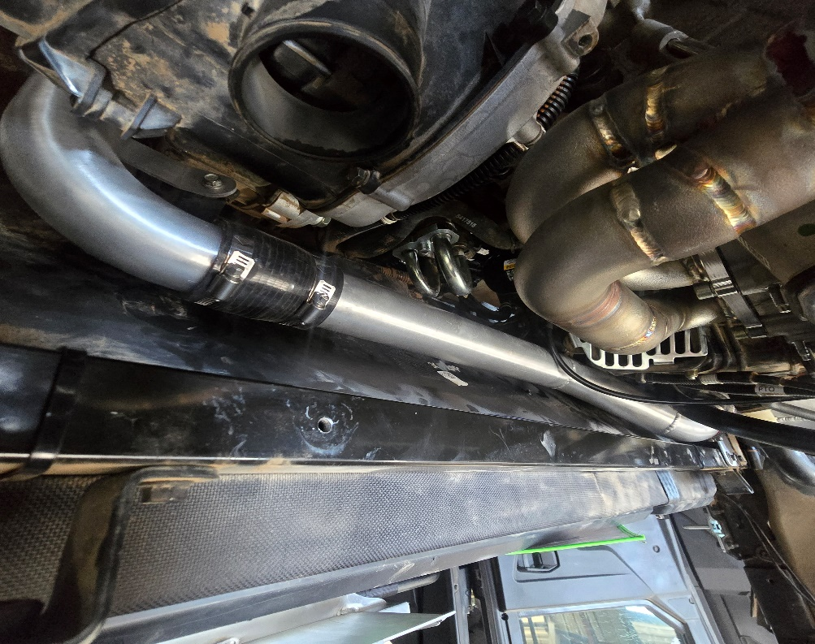
- Install air filter straight onto the turbo.
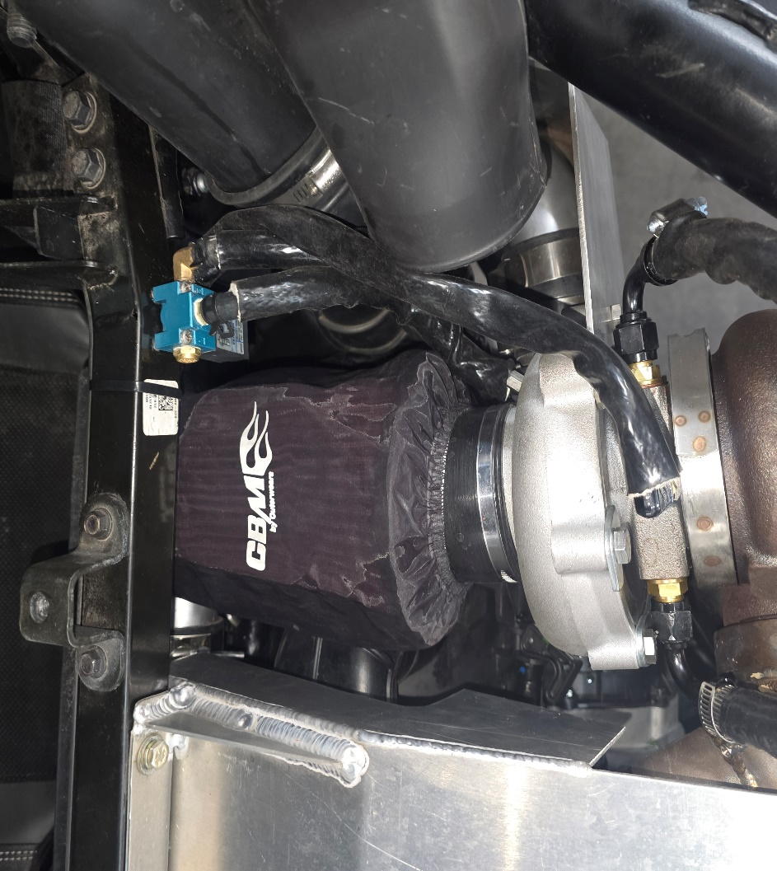
With supplied barb union. Extend crankcase ventilation hose to route towards oil catch can (barb circled)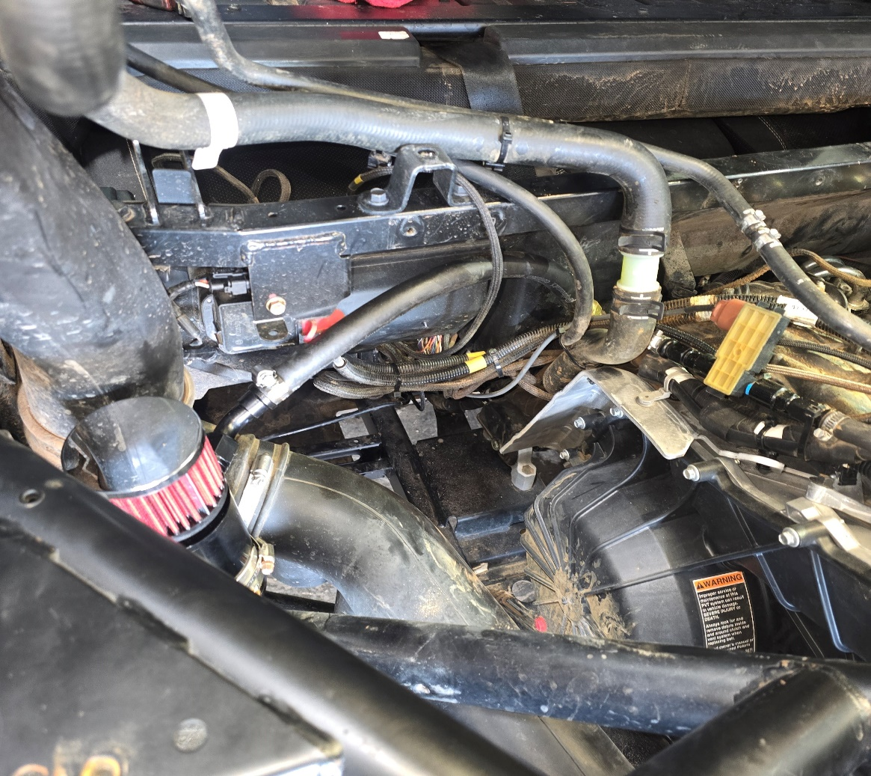
barb
- Install turbo charge tube with supplied clamps and connections. (Make sure clamps and facing horizontally so they do not interfere with bed installation.)
- Insall intercooler, using factory airbox mounting locations. Secure with factory hardware. Fan relay and harness ground are to be mounted directly in front of intercooler on firewall frame rail as pictured. It may be necessary to grind some paint away to create a good grounding surface for the ground connector.
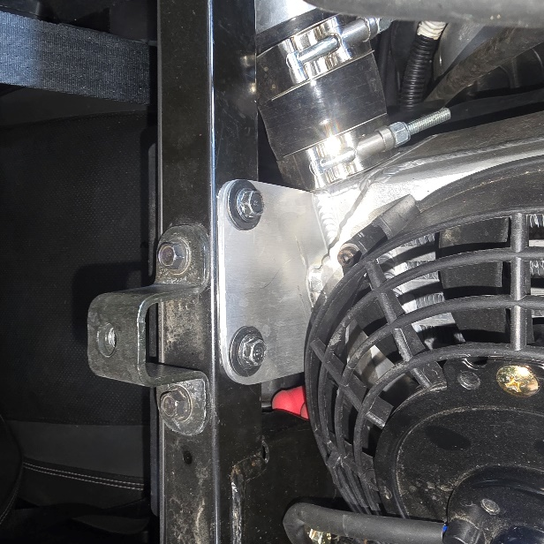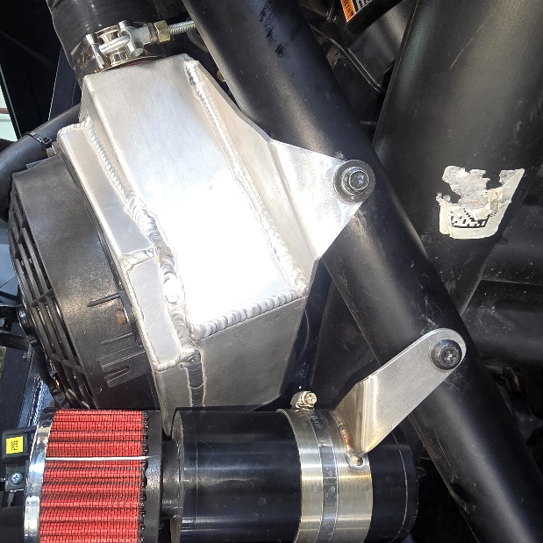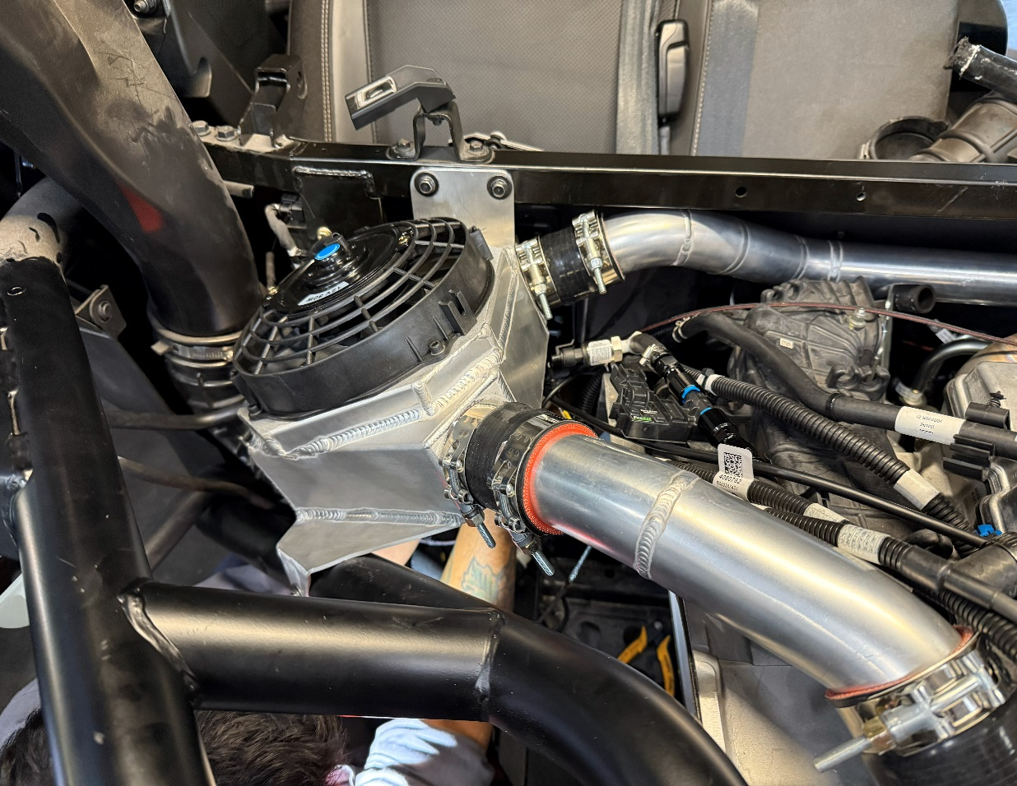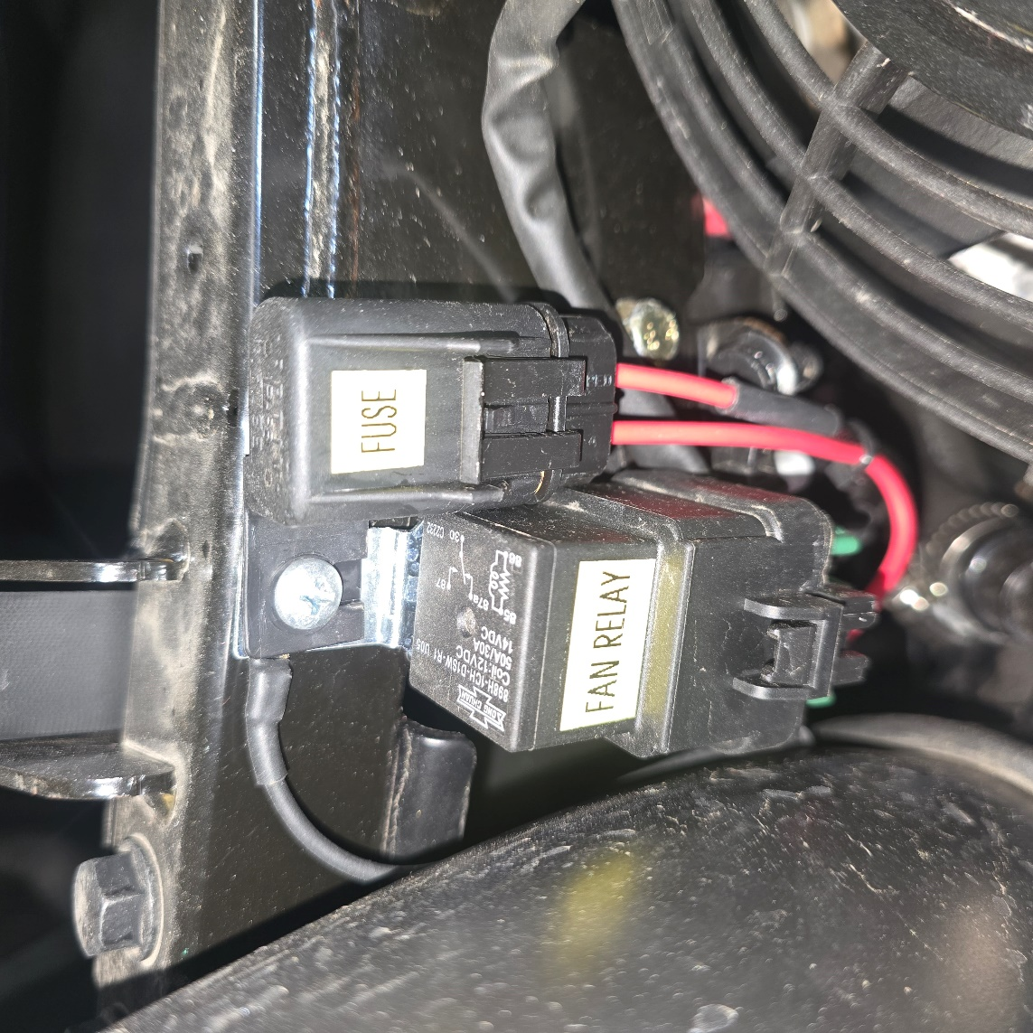
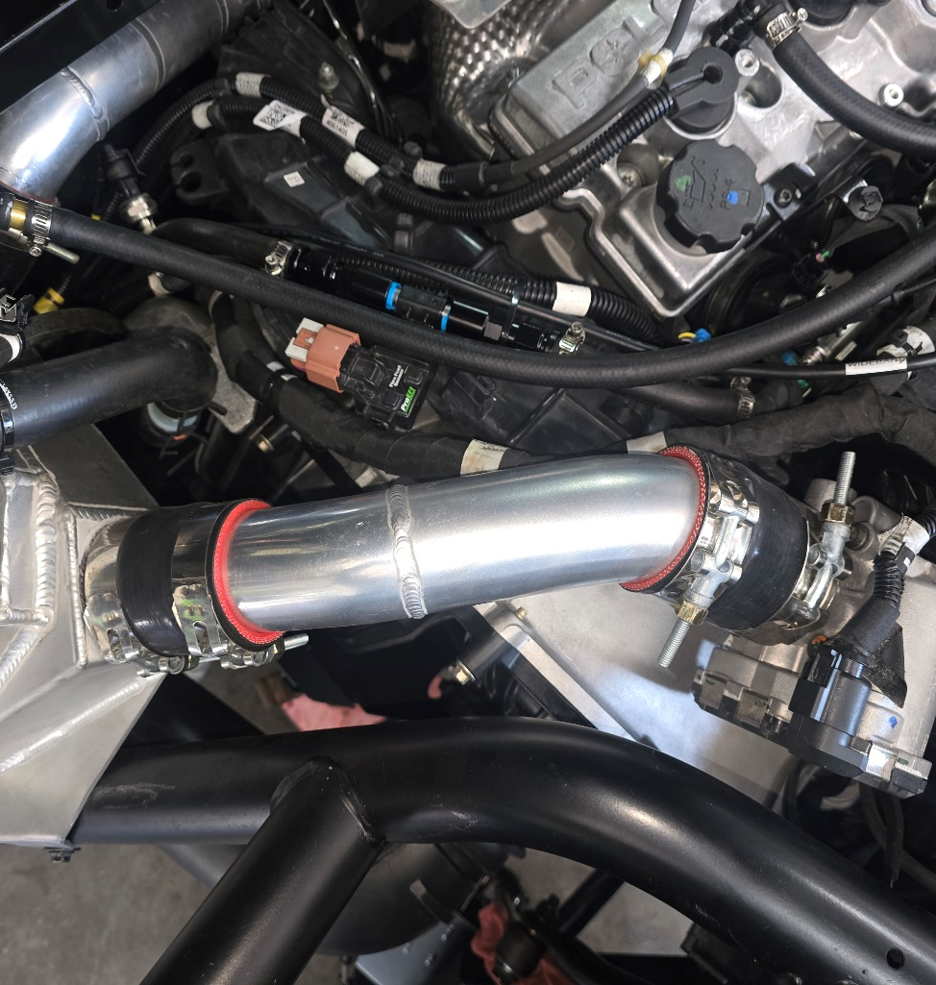
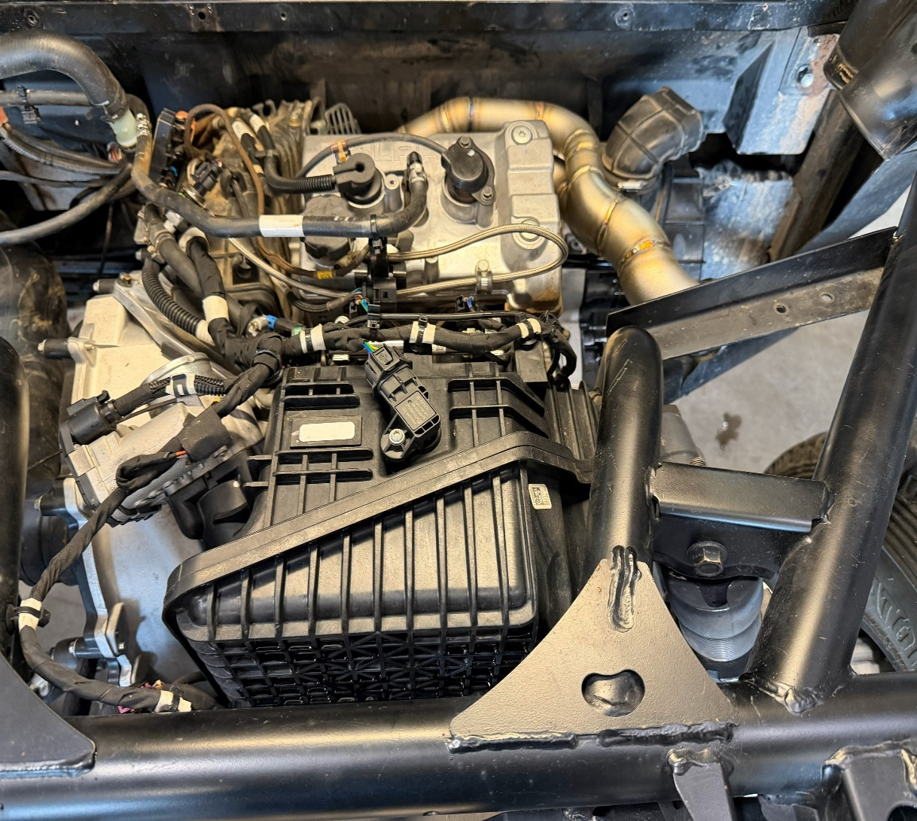
- Remove injectors, spark plugs and map sensor. Install the ones supplied by ProEFI. Be sure to lubricate o rings before installation, and reuse retention clips for injectors if applicable.
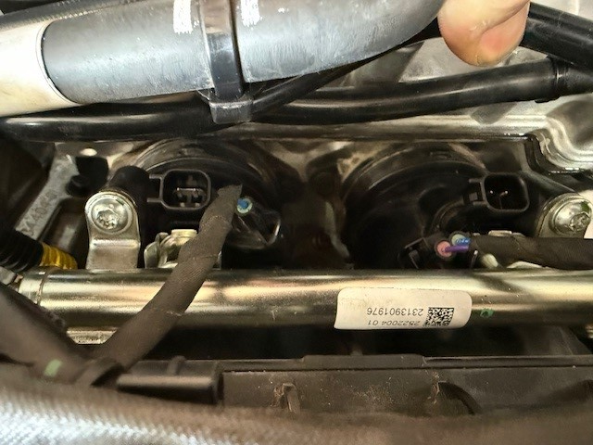
- Double check all connections and fittings at this time, making sure nothing is routed or touching any exhaust!! (If using remote boost controller, install it at this time, pictured above, on rear seat frame rail in front of air filter.
- Make sure all vacuum lines are routed away from exhaust or anything that can melt them and are securely fastened to the fittings. Failure to do so with result in engine damage.
- Vacuum line and boost control install
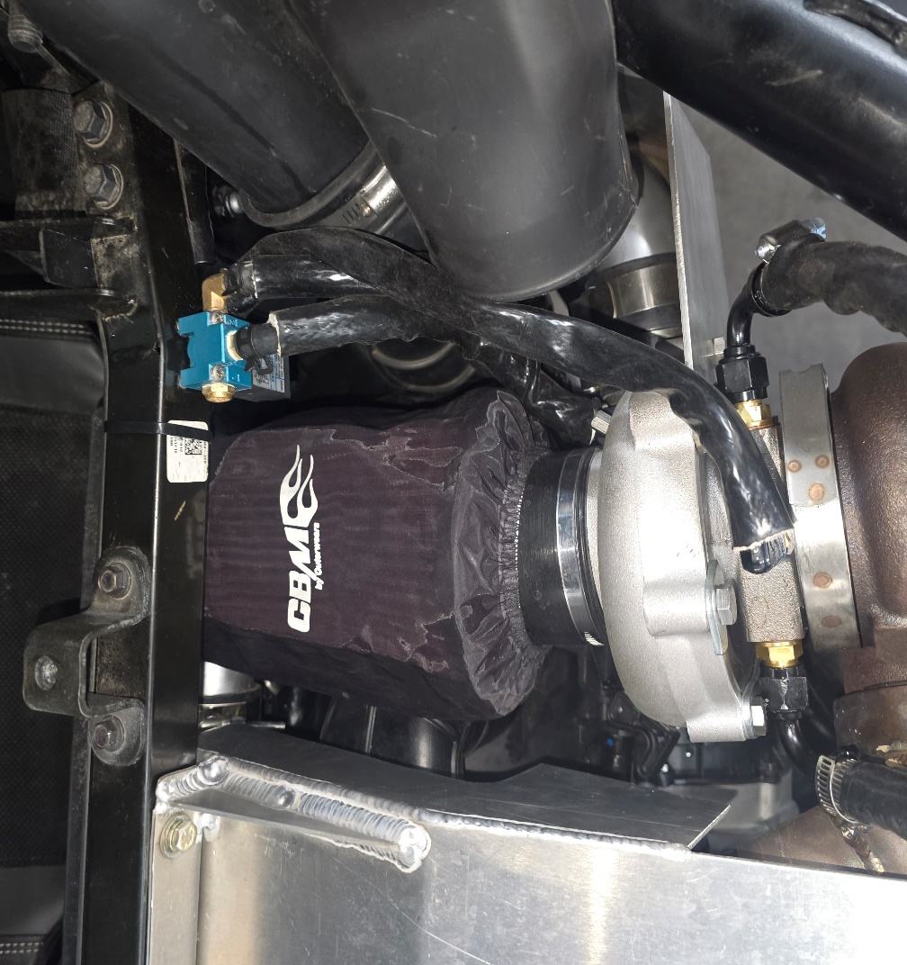
- Install straight barb fitting on compressor housing of turbo. On the boost control solenoid, install on frame rail as pictured. Unit will be mounted upside down. Port 1 will be the brass filter (left side) Port 2 will need a 90 degree barb fitting inserted(right side), facing forward. Port 3(front port) will have a straight barb fitting coming out of it. Wastegate line will go to port 2, fitting off of the turbo compressor will go to port 3. (Again, make sure vacuum lines are run in a fashion that they cannot be damaged. Failure to do so will result in engine damage!)
- Remove the belt cover. Replace the primary clutch with supplied weights and spring. Start with base weights depending on tire size, boost and fuel applications additional magnets may be needed. (if applicable.)
- Remove stock ecu, in panel behind drivers side rear passenger seat. remove driver seat for battery access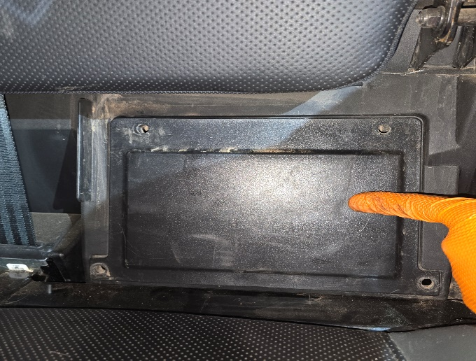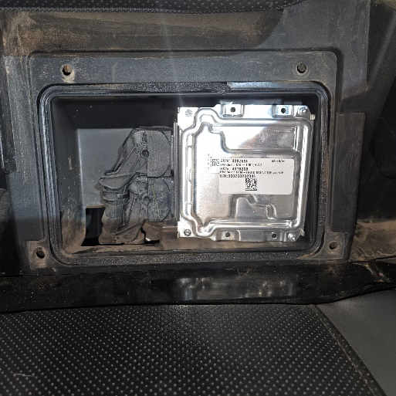

- Install ProEFI harness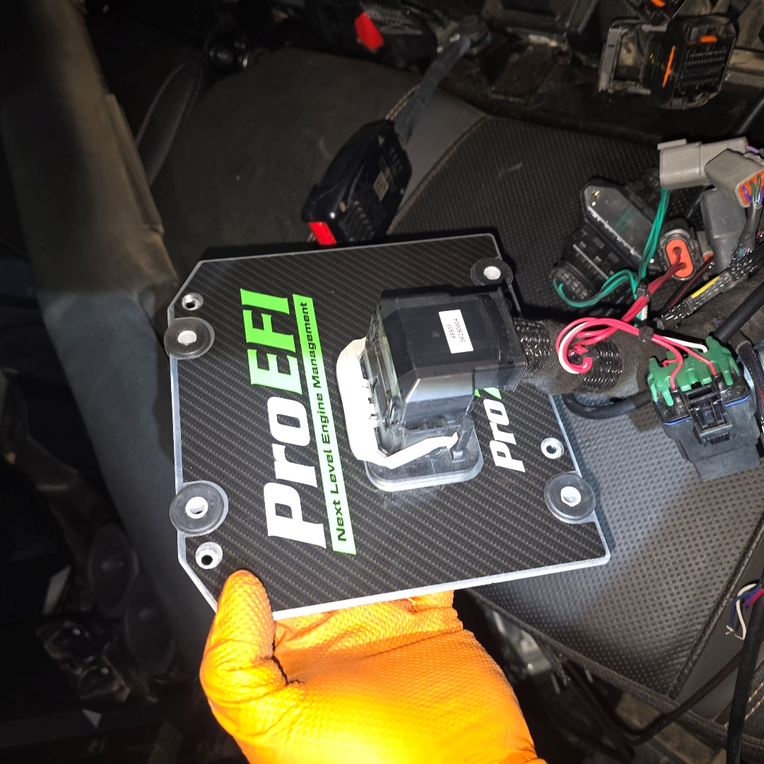
- Attach 12 v connection to battery (power wires must be fed under the vehicle between the floor and the splash trays towards the drivers seat where the battery is mounted.
- ecu mounted on back of cab by coolant reservoir in truck models. Ecu mounted under seat or in factory ecu location whichever is preferred for SUV models.
- It may be easier to feed the main ecu harness connector in from the rear of the vehicle to the inside of the ecu location. Secure and affix harness in a manner that is neatly kept and avoid loose wires hanging. Route all input/output sensor harnesses in plafe before securing all of the wires on the main harness at the ecu. 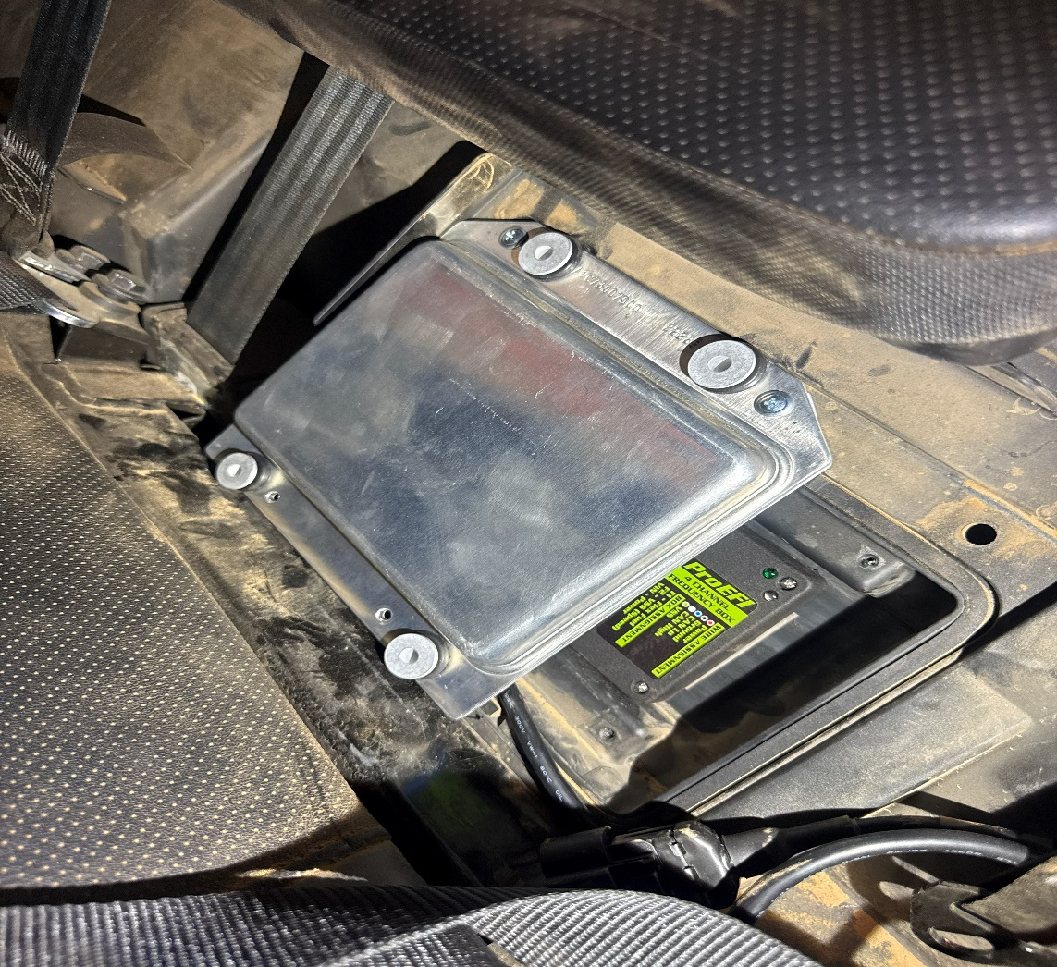
- Be careful not to bend any pins when installing harness and ecu!
- Run wideband o2 sensor above belt cover to back of car and install ProEFI supplied wideband o2 sensor.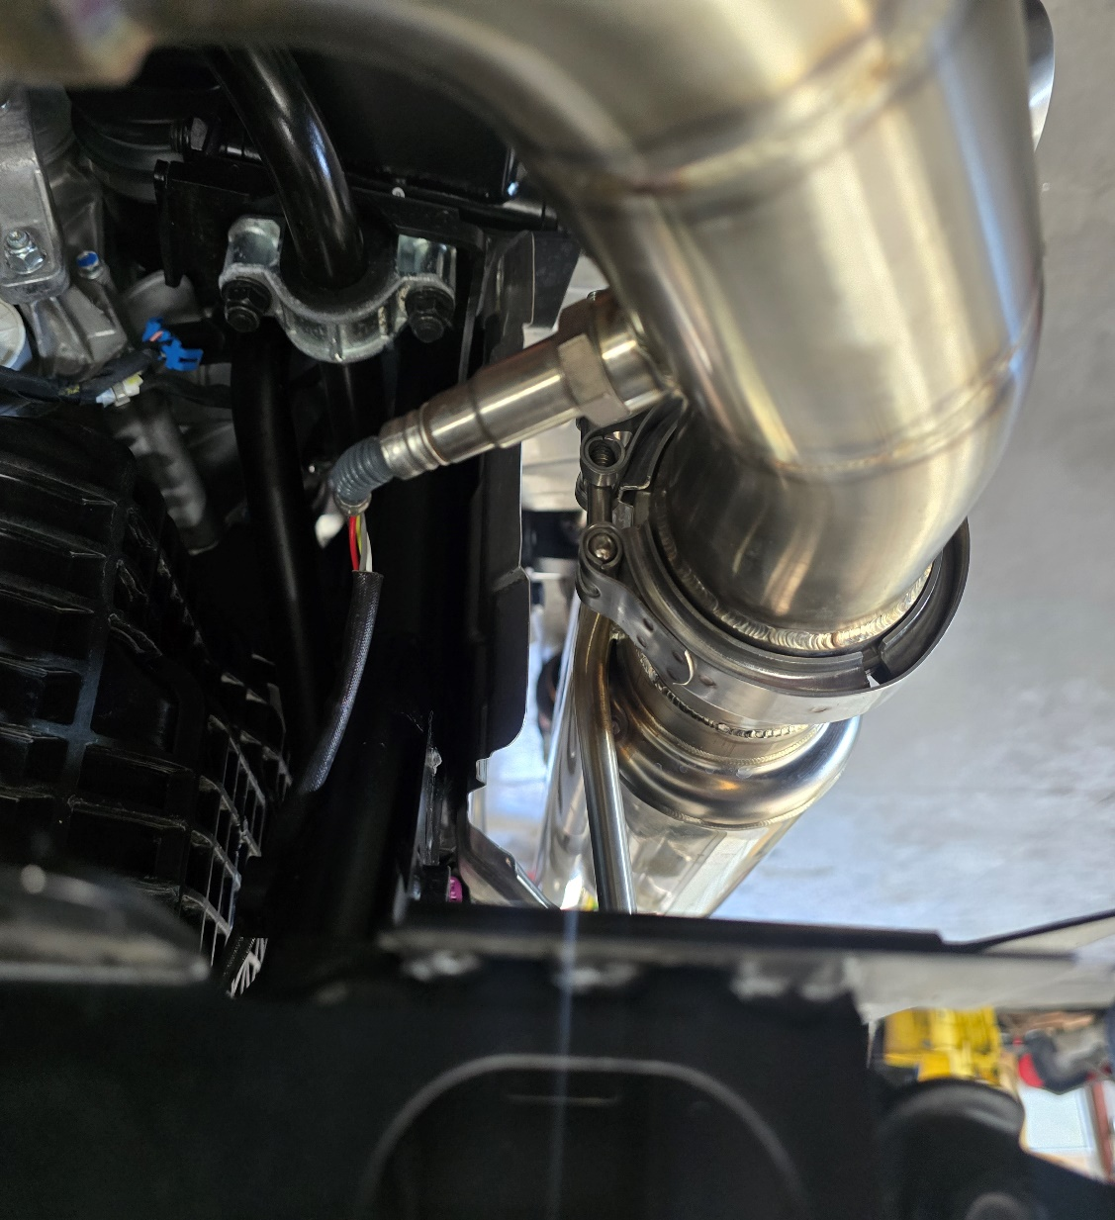
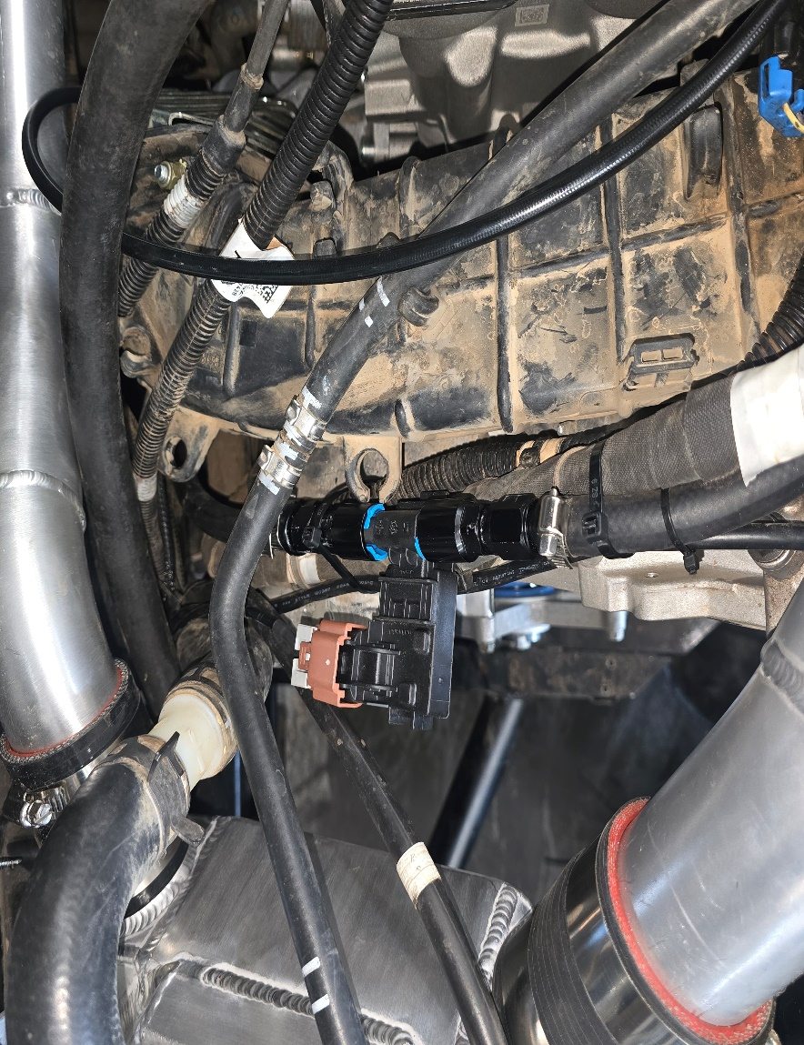
- If additional sensors and harnesses were purchased, please plug in and route cables to oil filter housing for oil pressure, and flex fuel wiring to top of motor next to valve cover. Install flex fuel sensors and or fuel pressure sensor at this time. (recommend replacing factory hard line with high pressure fuel injection rated 3/8 fuel line for ease of installation)
- Cut off and re use factory fuel line connections (fuel connection located in middle of car, above skid plate.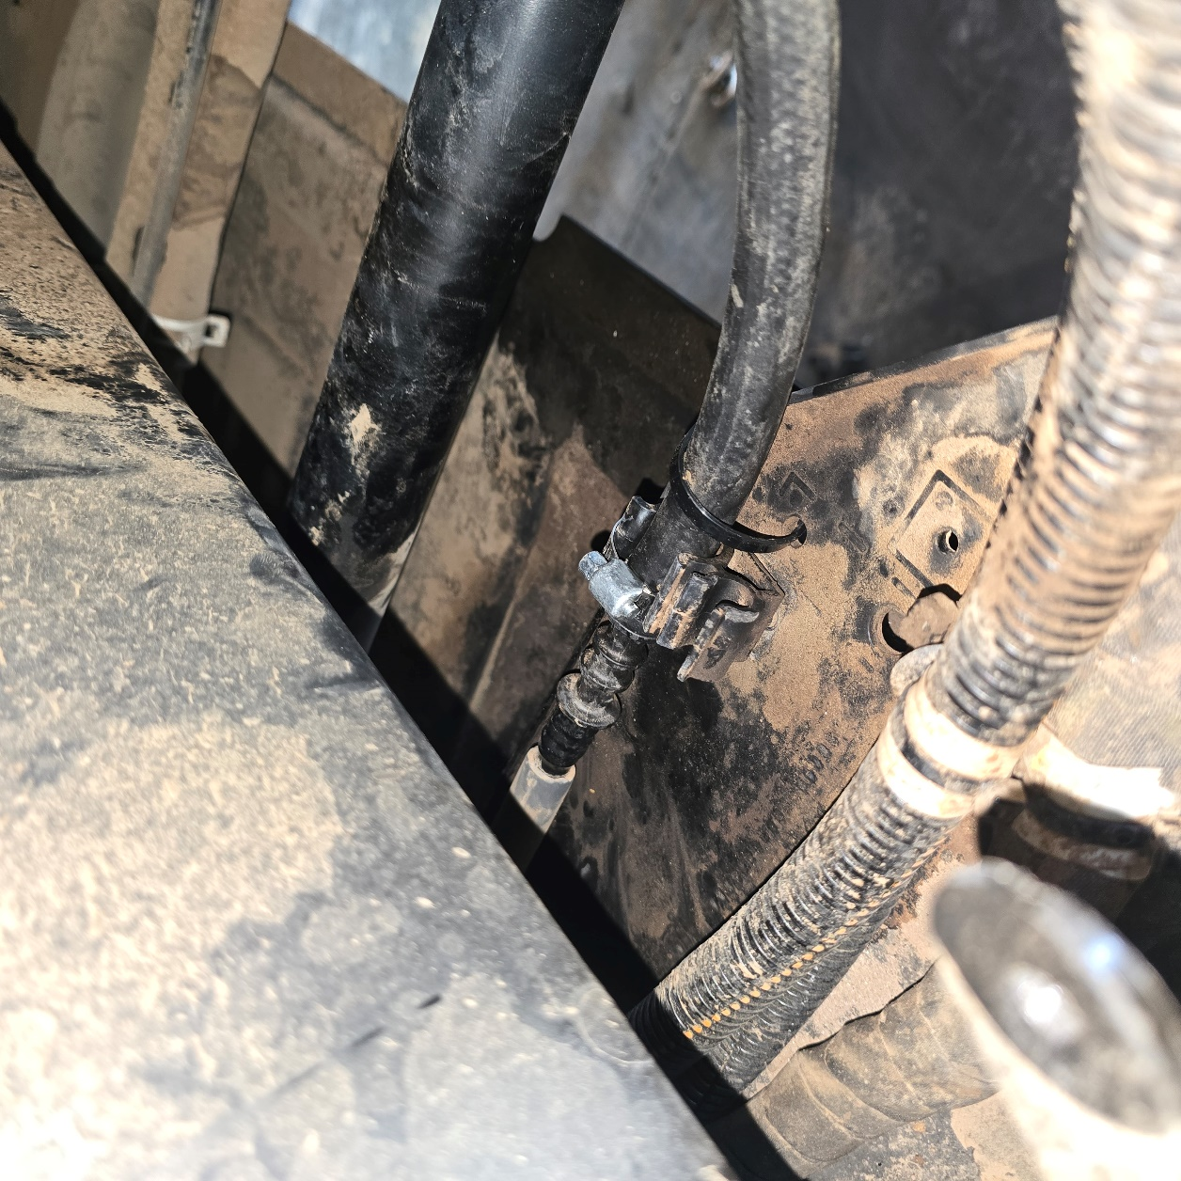
- Cycle key many times and check for fuel leaks. If no fuel leaks start car. Make sure the vehicle is in park and start. Inspect for oil, fuel or any leaks currently! If any leaks turn off immediately and repair leaks
- Currently your vehicle has a base file. If any other tuning is needed, you will have to download the ProEFI software from Proefi.com. https://proefi.com/software/
- Also download AnyDesk to the laptop you are using. (windows laptop only) for remote tunes https://anydesk.com/en
ProEFI highly recommends after installing contact tech support, having us remote in to your vehicle and check all parameters and get a data log & some test drives before installing bed or cab and starting your journey.
tech@proefi.com or 602-756-6486

