ProEFI Getting Started
Download the latest Software - Download
Setup – The single most important step in preparing to tune a vehicle is going through your calibration setup and making sure your engine, fuel system, and sensors are ALL set up properly BEFORE cranking the engine over for the first time! Overlooking any of these key steps will cause the rest of the system to function improperly. While you may be able to get the engine running and running well, as soon as you ask of anything differently than what was specifically dialed in (I.E. more boost, a change in flex fuel content, etc….) the systems calibration will be off, and engine damage may occur. Following these steps will help you have a smooth successful tuning session.
- Register your ECU – When registering the ECU, make sure to register the ECU to the customer’s name, email, and information, not the shop name. This is important for several reasons. The Trial period is 5 days, this is to allow time to send the email file in and register the ECU on our end. Do NOT wait until the trial is expired and expect us to rush your license! This is what the 5 day period is for. Normally it will only take a day or less, unless you send it in on a Friday, then it would most likely be Monday.
- Registering the ECU:
  - Activates the software license so the ECU can be connected to
  - Activates the warranty for the customer
  - Allows us to track any stolen ECU’s (yes, we have had to deal with this in the past)
  - Incomplete information or incorrect information will delay this process.
- Select the appropriate base map for your application. All of the base map and firmwares are on the ProEFI website FOUND HERE then by vehicle and ECU within that tab.
  - For Universal or non-vehicle specific applications, select the appropriate firmware needed for your application. The ‘key code’ for deciding which firmware you need is built in to the software under Setup/Instructions and is called ‘Firmware Decoder’. Contact your dealer or go through the Firmware decoder and write down the appropriate letters for your specific application. If you are unsure of what your timing pattern is, contact your Dealer or ProEFI Tech support (tech@proefi.com).
- After your firmware has been selected, flash the .Pro_xxx file (firmware file) in to the ECU. Pay attention to the screen during the flash process, you should see a clear ECU cycle, and a programming cycle complete by outlining a circle around the flash ECU icon. Once completed it will ask you to turn the power off for 60 seconds to reset the ECU. When that task is complete, you can power the ECU back on and connect to the ECU. Unless you have received a file with the calibration built in to the .Pro_xxx file, the calibration in the ecu will be blank (meaning base values, not meant to run an engine). Once the flash is complete, connect to the ECU and Save the file and name the file keeping the firmware name at the beginning of the file name. Keeping the firmware name as a part of the Xcal will help avoid confusion later and assist with any technical support required down the road. Once saved, re-open the software and select the ‘Offline’ mode. You can then select the file you have saved. Once the selected file is open, you can now begin going through the setup of the calibration for the vehicle at hand.
- If you are starting with a base calibration for your vehicle, follow these steps and verify functionality of all of the sensors installed
  - Swept cylinder Volume – Check and make sure the swept cylinder volume is accurate for you engine. This is in cc’s PER CYLINDER
  - Injector calibration – Make sure you have loaded in the proper injector data. This can be found in the help file on the injector setup page or you can load in a partial calibration using the partial calibration feature (See Step 5 subset o). If your injectors are NOT listed, contact tech@proefi.com for help.
  - Calibrate the throttle Sensor(s) Following the calibrate throttle procedure
  - Validate Manifold Pressure settings are correct and sensor is reading properly at key on (current atmospheric pressure). Note: Map Sensor does not update until key is cycled or Engine is rotating.
  - Validate Fuel Pressure sensor is setup correctly and reding correctly
  - Validate Coolant temp is reading correctly
  - Validate Air Temp Sensor is reading correctly
  - Validate any additional sensors added beyond factory are validated and working correctly (Widebands, Exhaust BP, Coolant Pressure, Trans Pressure, etc….)
  - Ensure V.E. map scaling is correct for the range and load/fueling type you intend to use (V.E. Throttle, Map Based, or MAF Based).
  - Ensure Spark Advance tables are scaled for the range you intend to use (I.E. if your running 35psi of boost scale the map out to some reasonable number beyond that point. The ECU will hold the last value on the map).
  - Ensure your target Idle is setup for the desired idle speed you want against the engine temperature for both ‘In Gear’ and ‘Neutral’ settings.
  - Go into the trouble shooting tab and under outputs for the appropriate ECU type make sure your outputs are set to the output you wish to use for that function. Note that no duplicates can be assigned for the 128/48 ECU’s if you have duplicates, that function will NOT work at all.
  - Go to the inputs tab and verify all of your inputs are set to the correct inputs for the function you are using. See the Input outputs sheet for notes on using the analog inputs for any additional ancillary devices.
  - An Application Engine Specification ‘Cheat Sheet’ is available in the software under ‘Setup/Instructions’, Application Engine Setup Notes . If you do not have a base calibration, any base calibration may be used as long as you have selected the appropriate firmware for your application. In the base calibration, make sure you enter the engine specific information in to your calibration if you are starting with a base calibration that was not for your specific engine.
  - The Partial Cal (Pcal) function (Video Here)is a very powerful tool and help save time during this step. Select the Base calibration you want to begin with (anyone will work fine), open that calibration off line. Once open, select the open icon in the top right corner.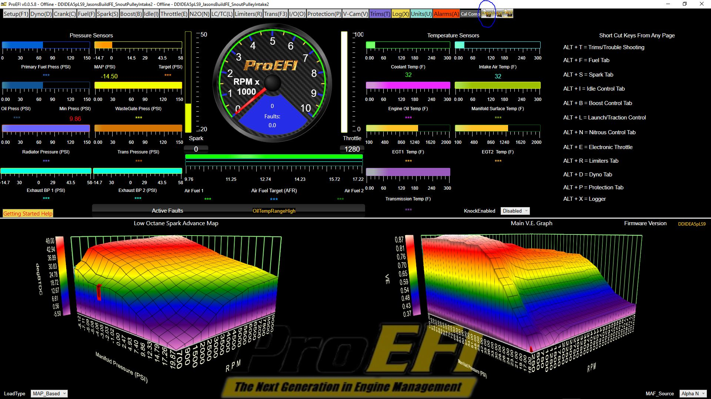 A pop up will come up explaining the calibration you select will overwrite values in the ECU, select OK.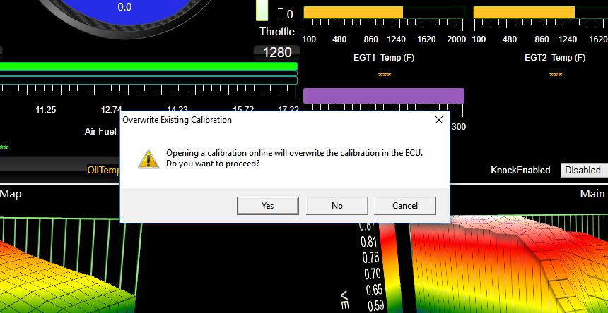 Navigate to the appropriate folder for the Pcal where the Engine Configurations are located. This is ECUFiles/Xcals/Partial Cals/Engine Setups by default.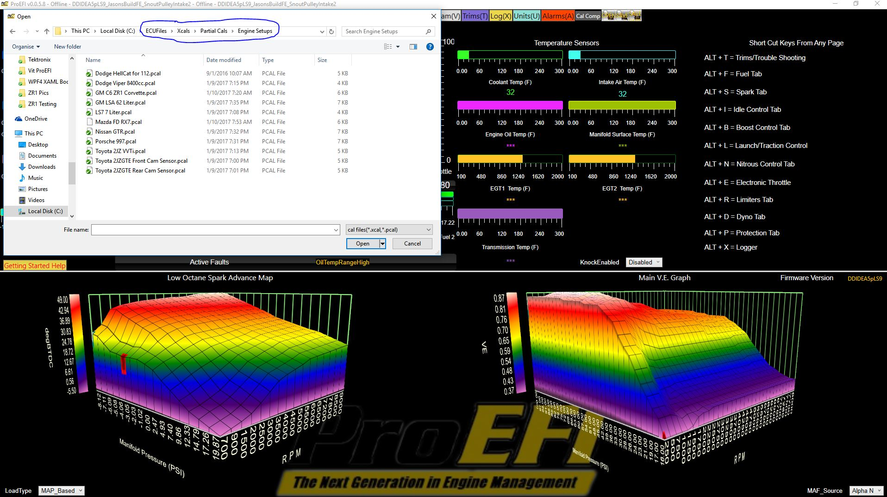 Select the appropriate Engine Configuration for your application. Once this step is completed, you can save the new calibration (rename it with some indication of what you want to indicate the steps completed), and you can continue to open other Partial cals for anything else you wish to bring in to this calibration. (I.E. Boost control, Traction Control, etc…) Save the completed file and then follow the steps to create a new ECU File in the help under the ‘Create ECU File’ button on the starting page (How to Video here). Your Engine Configuration file will change the following Engine Specific values.
  - TDC Offset – Sets the crank angle offset and is engine specific. Base calibrations will have this set. If your timing pattern is fixed, this should never move.
  - Firing order – Sets the crank angle firing degrees for each cylinder and is Engine Specific. This will be setup in the base calibration for your vehicle.
  - Number of cylinders – Sets the number of cylinders to be used
  - Swept Cylinder volume – Used in fuel calculations and is critical for a proper v.e. calculation CC’s per cylinder
  - Base Injector Phasing – See specific documentation on setting up injector phasing. The engine will still run if this is off, just won’t be optimal.
  - Combustion events per rev (half the number of cylinders on a 4 stroke, or the number of cylinders on a two stroke). Used to properly calculate fuel requirements.
  - Selection for Two Stroke Four Stroke is set appropriately.
  - Load Type – MAP based or APC based (See specific documentation explaining these types).
  - MAF Source –
    - Alpha N - Throttle based lookup on the ‘Y’ axis of the V.E. Table for true Throttle Speed Density.
    - Model From Map – Speed Density using Manifold Pressure as the ‘Y’ axis lookup on the V.E. table for typical manifold pressure Speed Density.
    - Use MAF Sensor – Use a Mass airflow sensor as airflow input.
- Go to the Setup Tab FIRST! Everyone wants to jump right in and start tuning the engine, but the problem is, if your setup isn’t right, your tuning will be WORTHLESS! You MUST setup the following options to configure the calibration appropriately for your application.
  - Basic Setup
    - Load Type – This will typically be MAP Base for speed density setups and boosted engines. If you wish to use APC based (Ideal timing method), be aware that the load axis for your timing maps will be based on Calculated Torque values so you will need to rescale your Load axis on the timing maps. Then you will also need to log torque values to determine where to change the timing numbers to properly tune the engine.
    - MAF Source – Typically will be Model from Map for Speed density setups, and will work like you would expect with your load axis being set up in manifold pressure. You can use a MAF sensor in either the 0 to 5v variety or Frequency type. Both can be setup up with transfer tables and the system becomes a true MAF based system when in this mode. The ProEFI is a TRUE Speed Density system when in the model from MAP Mode, so manifold pressure fueling is calculated automatically. There is no need to address fueling for increased boost pressure, other than the effects of backpressure from turbochargers at the higher boost levels. However, the ideal setup of Speed density is Alpha N for a number of reasons.
      - Your throttle blade changes the efficiency of the engine, manifold pressure does not! Using Alpha N allows you to finitely tune efficiency based on the blade position and how it affects the engine across the many throttle positions and RPM’s. This method typically takes a little longer to tune, but it is well worth it in the end. Fueling adjustments are made by Throttle % against Engine RPM.
      - Throttle response is significantly improved, and Accel fueling isn’t relied upon so heavily for transients. You MUST have an exhaust back pressure sensor installed and operational for proper fueling across varying backpressure ranges (I.E. when you turn the boost on a turbo charged vehicle up and down, exhaust backpressure significantly affects the volumetric efficiency of the engine).
    - Swept Cylinder Volume- This sets the displacement of EACH Cylinder in CC’s. This is a VITAL part of the fueling calculation and MUST be addressed. So if your engine is a 3.0 Liter 6 cylinder, divide 3000 (liters to cc’s) by the number of cylinders (in this case 6) and you get 500. If in the future you stroke this engine to a larger displacement, and change NOTHING else. This is the ONLY value that should need to be changed for the tuning if you have done your job properly on all of the other setup parameters.
    - Combustion events per rev – This option will always be half of the number of cylinders on a 4 stroke, and the number of cylinders on a two stroke and MUST be set up properly as well or your fueling WILL be off!
    - Vehicle Weight with Driver – This option is meaningless in the calculation for engine tuning, and is only used in the ¼ mile E.T. and MPH calculation.
    - Number of Cylinders – This option must be set appropriately.
    - Fuel weight in lbs – This option must be set for the fuel economy calculation to function properly.
    - Two Stroke or 4 Stroke – Must be set accordingly
    - Logger Setup –
      - Start Logger Above RPM – Sets the minimum RPM Trigger to start the logging condition when the other conditions are met
      - Start Logger Above TPS – Sets the minimum TPS point to Trigger the Logging condition when the other conditions are met.
      - Logger Off Delay Time – This option sets the after run on time when the Log conditions are unsatisfied.
      - Minimum Engine Run Time for Log – This option sets the amount of time the engine must be in the run mode before starting to log.
    - Cranking Spark Advance – This table sets the cranking spark advance against Engine RPM. This table is also located in the cranking tab. Typically at slower speeds (especially on a high compression engine) you want less timing (close to zero and in some cases even negative numbers are used) then as speed ramps up to full cranking speed, normal values are used (typically between 10 and 20).
    - Fuel Pump Override – This option is used to force the vehicles fuel pump to the On or Off position. In this screen, we want to force the fuel pump to the Off position by putting a ‘0’ in the Fuel Pump 1 Override option window, and then Set the override from Pass through to the override position. This forces the fuel pump off so when cranking the engine to set the ignition timing we can take fuel out of the equation and get consistent cranking speeds and NOT try to fire the engine until the timing is sync’d close. NOTE: Once the timing is close, the pump should be allowed to run and then the timing re-checked with the Engine Running, WHILE remaining LOCKED to verify timing sync accuracy!
    - Lock Spark Advance to – This option sets the total advance when in ‘Locked’ mode.
    - Spark Advance Lock/Unlock – This option locks the total timing to the value in the ‘Lock Spark Advance to’ option. The lock function is used so the ignition timing can be ‘syncd up’ with the engine using a NON-DIAL back timing light. WARNING!!!! You must unlock this option after timing sync is completed in order for the ECU to operate as normal.
    - TDC Offset for Timing Sync – This option is used to sync the mechanical timing being read with the light to what the ECU displays the ignition timing to be.
Advanced Setup – In base calibrations, these options will be setup, and should be changed using EXTREME CAUTION! Some of the options in the screen CAN Crash your ECU if not set properly.
- Engine RPM Filter Constant – This option sets the filter constant for the Engine RPM signal coming from the Crank Shaft. .020 is a typical value…EXCERCISE CAUTION if you decide to change this value as it will affect the tune of the engine.
  - Encoder Cam Sync Edge – This option sets the edge to use from the CAM sensor input. This is determined by looking at a scope trace and selecting the fast edge and the edge that is furthest away from the adjacent Crank Edge. Changing this edge WILL affect your ignition sync settings
  - Encoder Sync Edge – This option sets the Edge to be used from the Crank Encoder teeth. Changing this edge WILL affect your Timing Sync.
  - Crank to Run RPM – This option sets the RPM in which to transition from the Cranking Mode to the Run Mode. Fueling and timing will switch from Cranking Fuel and Cranking Spark to Run mode fueling and Run Spark at this point. (Typically 300 to 350 RPM)
  - Crank to Stall RPM – This option sets the transition point to go from Cranking mode back to Stall Mode. (Typically 100 RPM)
  - Run to Stall RPM – This option sets the transition point to go from the Run mode to the Stall Mode. (Typically 100 RPM)
  - Stall to Crank RPM – This option sets the transition point to go from the Stall Mode to enter the Cranking Mode. (Typically 50 RPM).
  - Steady State Coolant Temp – This option defines what a warmed up Engine Temperature Condition is expected to be. This is used in for various calculations including O2 Warm Up states.
  - ECT Warm Up Time Const. for NECCT (Seconds) – This option sets the warm up time constant for the O2 Sensor on re-initialization.
  - Steady State RPM Tolerance – This option defines the steady state rpm condition to be ‘Less than this value’ change per second to be steady state. Typical values are 250 to 350 rpm/sec.
  - Steady State RPM Increasing Filter – This is the time constant filter used when determining RPM rate of change increasing.
  - Steady State RPM Decreasing Filter – This is the time constant filter used when determining RPM rate of change decreasing.
  - Steady State Load Tolerance – This option defines the steady state Manifold Pressure Condition to be ‘Less than this value’ of change per second to be in the steady state load. Typical values are 20 to 30 Kpa or 3 to 5 psi.
  - Steady State Load Increasing Filter - This is the time constant filter used when determining Load rate of change increasing.
  - Steady State Load Decreasing Filter - This is the time constant filter used when determining RPM rate of change decreasing.
  - Run Latch TDC Count – This sets the number of cycle ‘Syncs’ needed to transition in to the Run Mode.
  - Firing order – This table sets the firing order for each ignition event in crank degrees from Cylinder #1 TDC Compression. The first cell is connected to EST1, next to EST2, and so on. These should be wired by CYLINDER, NOT BY FIRING ORDER!!!! The values in this table will dictate when that cylinder fires. This gives you the flexibility to run Odd fire engines, as well as maintaining fault integrity to be directed to the offending cylinder.
    - So for example, a 6 cylinder with an even firing order of 153624, you would have entered in the table – 0,480,240,600,120,360
  - Non Volatile Restore On First Startup – This Option Should be set to ‘Load Factory Defaults on Next Start up’. IF YOU CHANGE THESE OPTIONS, MEMORY WILL NOT PROPERLY STORE ON CALIBRATION CHANGES AND FLASH’S. THESE OPTIONS ARE ONLY IN HERE TO MAKE SURE YOUR CAL IS SET PROPERLY.
  - Non Volatile Restore On Start up – This should be set to ‘Load Saved Application Values on Next Start Up’. IF YOU CHANGE THESE OPTIONS, MEMORY WILL NOT PROPERLY STORE ON CALIBRATION CHANGES AND FLASH’S. THESE OPTIONS ARE ONLY IN HERE TO MAKE SURE YOUR CAL IS SET PROPERLY.
  - System Trigger Setting – This value should be set to 5 on V3 and later versions ONLY. Setting this to 5 on V2 Versions can Crash your ECU and make it so you have to return it to your Dealer for reboot.
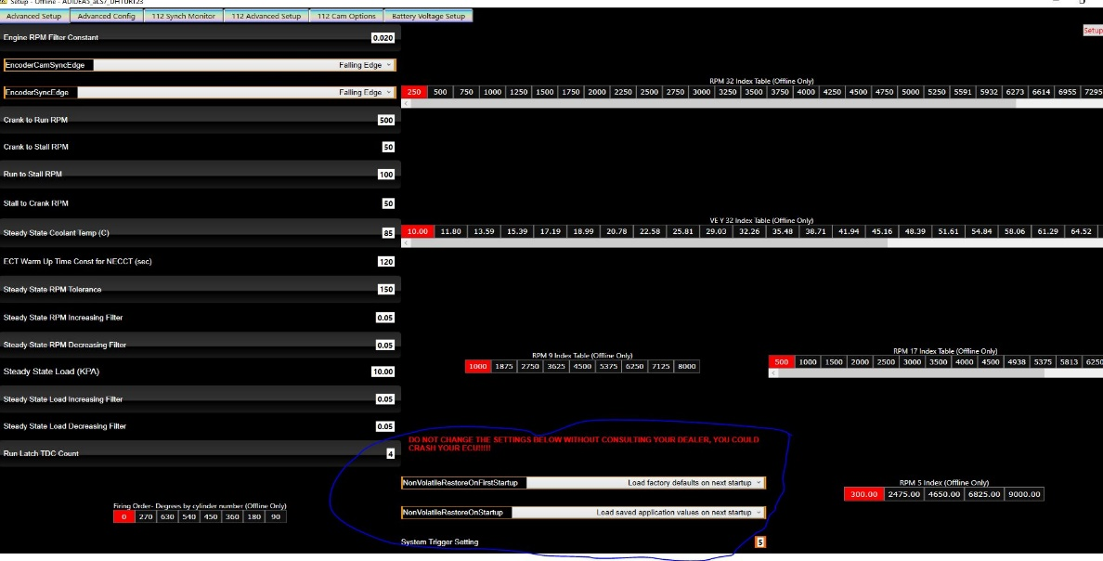
Fuel System – The Fuel system setup is CRITICAL to getting the system set up properly. ProEFI’s exclusive fuel pressure feedback system helps the user monitor and regulate the performance of the fuel system installed in to the vehicle. In the event of the fuel system falling short in supplying fuel to the engine, the ECU will compensate up to the flow capabilities of the injectors and shutdown definable things such as boost pressure, turning off nitrous, activating a rev limiter etc… to protect the engine from damage.
      - Primary Injector Flow Rate – This option sets the flow rate of the injectors (in CC’s per minute) based on the flow pressure stated in the ‘Primary Injector Rated at Pressure’.
      - Primary Inj Flow Rated at Pressure – This option sets the pressure used in the flow rating of the Primary Injectors.
      - Primary Base Fuel Pressure – This option tells the ECU where your base fuel pressure is set (no vacuum reference applied). This is then used to determine if your fuel system is working properly based on the Primary Fuel system type setting (Map referenced, Return-less (constant Pressure), Return-less with a sensor (constant Pressure)). A fault is then triggered once the variance exceeds 10%. This variance value is fixed and cannot be adjusted as it indicates the maximum tolerable variance in a fuel system. If you are exceeding a 10% variance, you have issues to address in the fuel systems supply setup.
      - Inj Current Select – This option will set the current capability of the Injector drivers. Note that 6 drivers are 3amp/1amp capable, and 6 are 6amp/2amp capable. Refer to your pin out sheet for driver allocation. If your injector load is less than 1.6 ohms, you will need to address the drivers used to drive them. Most injectors are above this impedance however, so you won’t have to worry about this setting typically.
      - Primary Injector Offset – This option sets the value needed to obtain as linear of a response from the injector as possible. Remember that injectors are relatively linear up to about 90% duty cycle (some a little more, some a little less), so we want to stay under 90% duty cycle at peak power for the best and safest results.
      - Primary Injector Min Duration – This option sets the minimum on time the ECU can request of the injector to prevent ‘stalling’ fuel through the injector. If too low of a pulse width is requested, no fuel will travel through the injector and create a misfire. This option prevents that situation from happening.
      - Primary Injector Duty Max – This option sets the maximum allowable duty cycle for the injector to operate at. This option also sets the fault condition when a value higher than this is requested. This allows the user to compensate for a loss in fuel pressure up to the point of injector over run, and then trigger a fault to shut the system down and prevent engine damage.
      - Peak Hold Duration – This option sets the Peak duration of the Peak and hold system. Typically this value is 1.5 to 2 ms. If you are using a saturated injector, this value should be zero, although the ECU knows when there is no current flow and will run in saturated mode regardless.
      - Cylinder 1-12 Injector – These options assign the injector drivers to cylinders.
      - Flex Fuel Present – This option tells the system whether or not a flex fuel sensor will be used on the Primary fuel system.
      - Low Octane/High Octane Primary Stoich Set point – This option sets the Stoich point for the Low Octane/High Octane Primary fuel system. This allows the user to easily change between fuel types without completely recalibrating the fuel maps. Note: When using a flex fuel sensor, these values are overridden with the information from the flex fuel sensor.
      - Battery Voltage offset – This table sets the Battery Offset for the injector to compensate for Voltage changes to keep the flow rate of the injector accurate.

