ProEFI Bluetooth Data Logger
Download the app form your app store onto your phone, plug the ProEFI Bluetooth logger into the car’s comm cable connector off the ProEFI harness, and key on the car.
Then open the app, and watch the app automatically recognize the Bluetooth logger to connect.
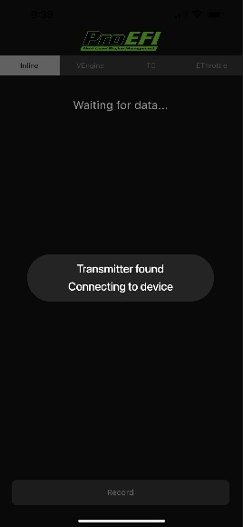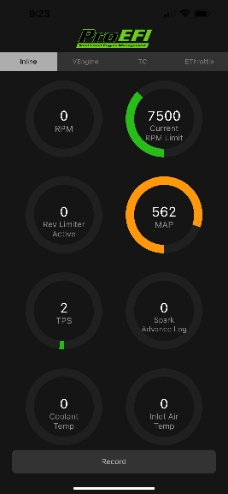
…swipe right to reach the setup/options screen….
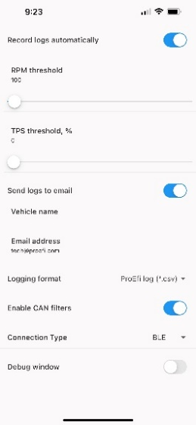
Here you can set the values you want for auto logging, as well as enter the email address you want the logs to send to… swipe left to get back to the main logging screen.
At the top of the main screen there are tabs for logging templates. Select the desired template. If you wish to log everything on the CAN, return to the setup/option screen and hit the switch to disable the CAN Filter. Otherwise, if the CAN Filter switch is enabled, the app will automatically log the selected template you choose from the main screen. And those values from the desired template will display on the main phone screen.
Once the vehicle is keyed off, the app will automatically stop the log and prepare the email to be sent. The app will then pop up the notification requesting to send the email. Hit send, the email will be directed to the email address that was added on the setup/option screen.
To manually log, select Record at the bottom of the main phone screen. To end the log, hit stop, then key off the car.
To create custom templates, you open the ProEFI software, open the Strip chart logger, select the channels you want to log, save that template, if you have ones already configured, you can load those on to the phone and select those directly with the phone connected to the PC or by emailing yourself the file and saving it from your mail app to the phone.
A long press on one of the template buttons or ‘Empty’ button will prompt you to load the .tem file from the location you saved it on your phone.

